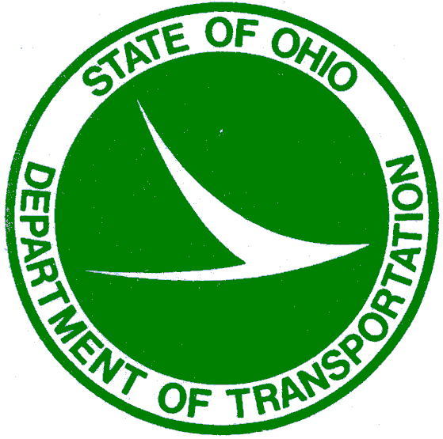
Ohio Department of Transportation
LPA PROGRAM FINAL REPORT
FINAL REPORT

PID #: | LPA:
Project Name (C. R. S.):
Project Description:

I certify that the subject project has been completed. The contract was administered and the work inspected under my general supervision. The LPA acted in good faith to inform and enforce with the contractor all the requirements of the plans and specifications. The LPA successfully implemented and complied with all environmental commitments.

The materials incorporated into the project were found to be in relative conformance with the contract requirements and the material documentation on file adequately reflects the quantities installed. Overall, the work was completed in substantial conformity to the approved plans and specifications and when necessary materials tested for conformity to expected standards.

The attached cost reimbursement information is correct and accurate to the best of my knowledge. There are no additional future financial obligations due by ODOT to be either paid to the contractor, or reimbursed to the LPA. The final invoice is attached as part of this report.

Further information and the project file will be kept for a minimum of three (3) years and can currently be found at this address:

 | CERTIFIED BY Local/ Person in Responsible Charge:
Signature: |  | Date:
Name:
Title:
Affix State Of Ohio Engineer’s Seal below if applicable

 | CERTIFIED BY Construction Project Engineer if applicable:
Signature: |  | Date:
Name:
Title:
Affix State Of Ohio Engineer’s Seal below

